NUMPY PROGRAMS

1. Creating Arrays

AIM : To write a Python program using the NumPy library to create and display one-dimensional and two-dimensional arrays, arrays of zeros and ones, an identity matrix, and an array using arange().

ALGORITHM :
- Start the program.
- Import the NumPy library using import numpy as np.
- Create a one-dimensional array using np.array().
- Create a two-dimensional array using np.array().
- Create a 3 × 3 matrix of zeros using np.zeros().
- Create a 2 × 4 matrix of ones using np.ones().
- Create a 3 × 3 identity matrix using np.eye().
- Create an array of even numbers from 0 to 8 using np.arange(0, 10, 2).
- Display all the arrays using the print() function.
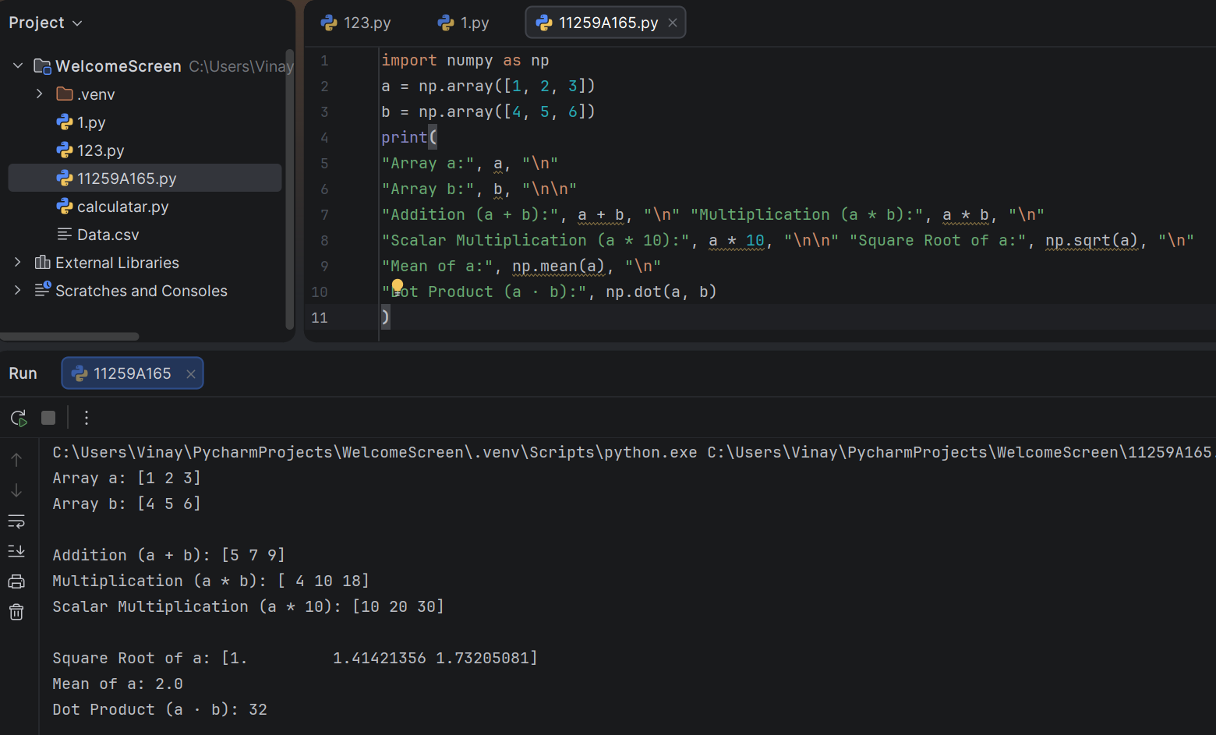
- Stop the program.

RESULT : The program successfully creates and displays one-dimensional arrays, two-dimensional arrays, zeros, ones, an identity matrix, and a range of numbers using NumPy .
2. Array Operations

AIM : To write a Python program using the NumPy library to perform arithmetic operations on arrays, scalar multiplication, square root, mean calculation, and dot product.

ALGORITHM :
- Start the program.
- Import the NumPy library using import numpy as np.
- Create two NumPy arrays, a = [1, 2, 3] and b = [4, 5, 6].
- Display arrays a and b.
- Perform element-wise addition using a + b.
- Perform element-wise multiplication using a * b.
- Perform scalar multiplication using a * 10.
- Calculate the square root of each element in array a using np.sqrt(a).
- Calculate the mean of array a using np.mean(a).
- Calculate the dot product of arrays a and b using np.dot(a, b).
- Display all the results.
- Stop the program.

RESULT : The program successfully performs array addition, element-wise multiplication, scalar multiplication, square root, mean calculation, and dot product using NumPy.

3. Indexing and Slicing

AIM : To write a Python program using NumPy to create a two-dimensional matrix and perform element access, row selection, column selection, and sub-matrix extraction.

ALOGRITHM :
1. Start the program.
2. Import the NumPy library using import numpy as np.
3. Create a 3 × 3 matrix containing the elements 10, 20, 30, 40, 50, 60, 70, 80, and 90.
4. Display the matrix.
5. Access and display the element at index [1, 2].
6. Access and display the first row using matrix[0, :].
7. Access and display the second column using matrix[:, 1].
8. Extract and display the top-left 2 × 2 sub-matrix using matrix[0:2, 0:2].
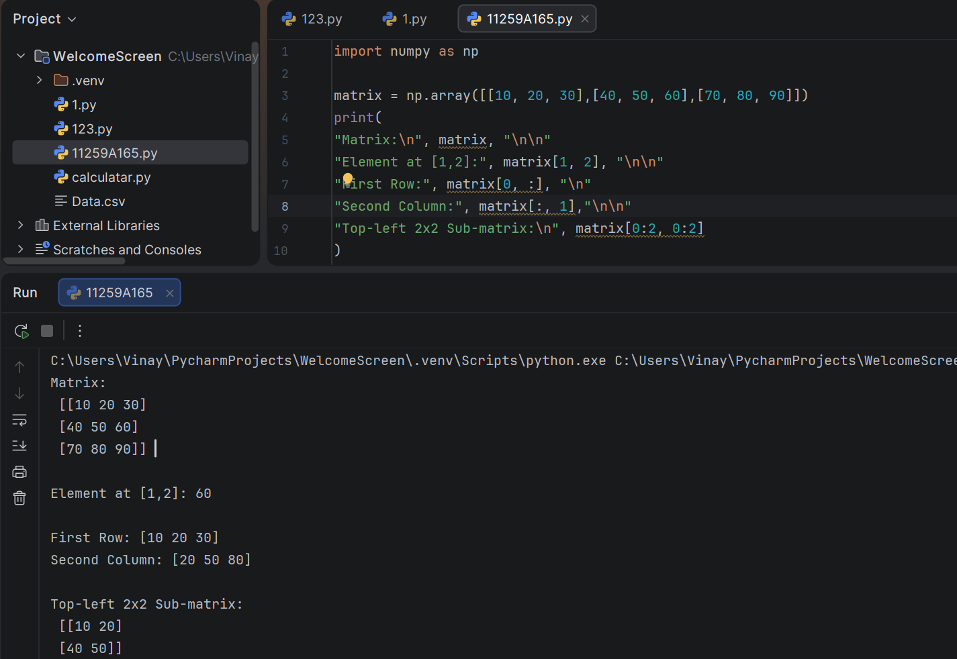
9. Stop the program.

RESULT : The program successfully demonstrates matrix creation, element access, row selection, column selection, and sub-matrix extraction using NumPy.

